Personal, Social, Emotional Development
- Playing name games and cooperative games
- Why do we have zoos? How should zoos treat the animals in their care?
- Have you been to a zoo? Recount what you saw and did there. Which animals were your favourite(s)?
- What did they do to make the animals happy?
- “Giraffe’s can’t dance” how did Gerald feel when he thought he couldn’t dance? He persevered and then how did he feel at the end? Have you ever felt this way?
- Regulation station – being able to recognise our own feelings and how others might feel

Maths

- Look at the pet carriers in Dear Zoo. Why did they all need to be different? What can you fit in each carrier?
- Can you order the animals from the story by size (height, length, weight) and use appropriate vocabulary
- Line up and count the animals from either story – “how many?” Can you write or find the number for each set?
- Sort animals by different attributes: legs, fur, feathers, patterns for example and compare each set
- Collect information – what is your favourite animal? Do you have a pet? How many? Find ways to collect the data
- Positional language to describe where the animal is (on the roof, in the box) or where to find an animal (next to the shed)
Expressive Arts and Design
- Explore animal patterns: can you recognise the animal they are from? Use different materials to make different patterns (paint, paper, collage, etc)
- Can you make a home for a chosen animal – junk modelling (joining materials in different ways), playdough and sticks, for example
- Make binoculars for the safari
- Use instruments to make different animal sounds (to go with the stories)
- Using tools to cut fruits: taste test fruits from the Handa’s surprise
- Songs - “(name) had a zoo – e-i-e-i-o…”; “10 elephants came out to play…”; walking through the jungle”; 5 little monkeys swinging in the trees”; “down in the jungle”

Physical Development
- Use playdough and modelling skills/tools to make different animals – roll a snake, pinch a feather on a bird, poke eyes, scratch fur marks onto bears, join legs and beaks, for example. Use small world animals to make tracks in playdough
- Use building materials to create dens, crates to build a role play zoo and ride on toys to go on safari
- Can you balance a basket on your head like Handa?
- An animal obstacle course – be tall like a giraffe, slither like a snake, jumpy like a frog (preparing for sports day too!). How might different animals move?
- Movement and small games skills – throw, catch, jump, run, etc

Literacy
- Listen, join in with, perform the story (Dear Zoo) using books, story maps, pictures and prop’s to sequence the story
- Alliteration: enormous elephant, spotty snake, tickly tiger
- “I wrote to the zoo to send me a pet…” children to make own flap book using the repetitive phrases and hear/say/write sounds
- Create a class alphabet zoo using the initial letter of each animal
- Mark make using a checklist as you find bugs in the garden or animals on a zoo safari
- Make signs and posters for the role play areas
- Other stories: supermarket zoo; Poo in the zoo; The selfish crocodile.
- Introduce the illustyration for the single sounds in Read, Write Inc (older children primarily)
- Contin ue to learn to write and recognise own name

Owlets Nursery:
Summer 1, 2024
“Dear Zoo”

“Dear Zoo” by
Rod Campbell

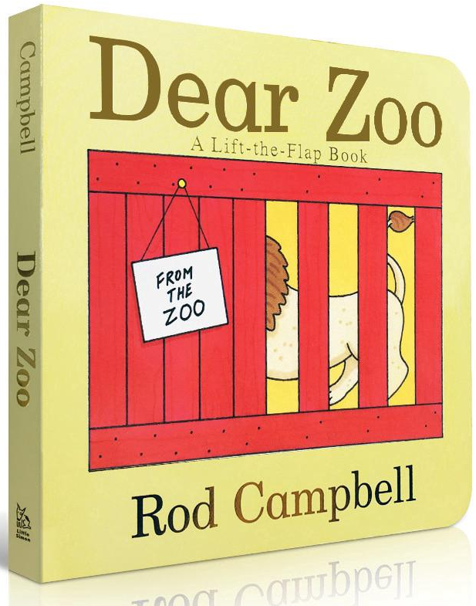
Communication and Language
- Listen to the story “Dear Zoo” (including Singing Hands Makaton story https://www.youtube.com/watch?v=XoHn8rLj9pc ; https://www.youtube.com/watch?v=KsHXDPxozTk dear zoo song )
- Learn the names of different animals and describe characteristic: the giraffe was too tall, the camel was too grumpy, etc (introduce descriptive vocabulary)
- Who am I? Describe or guess an animal - number of legs, fur or feathers, the noise it makes
- “I spy” games
- Learn Makaton signs for wild, zoo and farm animals
- Share animal stories
Understanding the World
- Sorting animals into wild/zoo, farm animals and pets – can wild animals be pets?
- What are the habitats like for wild animals – those who live in hot/cold countries. Why do we need to keep some animals in zoos or preserves (conservation, breeding programmes); can you make your own small world zoo?
- Explore different websites (London Zoo, Chester Zoo, San Diego Zoo) to find out about animals
- What would it be like to be a zoo keeper? What tasks would you need to do for different animals? Role play a zoo (extending to include a safari tour and a café or a fruit shop)
- Taslk about your favourite animal? Why is this your favourite?

