# BURSTOW PRIMARY SCHOOL BEHAVIOUR FOR LEARNING POLICY

Review Date: May 2025

Agreed by Governors: May 2024

**Rational, Aims and Approach**

**Rationale:**

Inclusion and the development of positive social, emotional and learning behaviours are at the heart of our Behaviour Policy.

**“Good behaviour in schools is central to a good education. Schools need to manage behaviour well so they can provide calm, safe and supportive environments which children and young people want to attend and where they can learn and thrive. Being taught how to behave well and appropriately within the context they’re in is vital for all pupils to succeed personally.” DFE Behaviour in school, July 2022**

We know and remember that **ALL BEHAVIOUR IS A FORM OF COMMUNICATION**. We understand that unsocial behaviour in children is often communicating an emotional need or a need for support and can be dependant upon the age and stage of the child. Staff work with parents to understand the function of the behaviours and to identify the best ways to work with the child to develop strategies to regulate more effectively and make more prosocial choices. Within this, there must always be clear boundaries and behavioural expectations.

Everyone feeling safe and being able to learn are paramount. We encourage a growth mind-set and believe behaviour can change for the better with the right support. We understand that positive behaviour, like other skills and abilities, is also something that can be learned.

**“You can’t teach a child to behave better by making them feel worse. When children feel better they behave better.”**Pam Lee

**Our core values:**

**Love, Trust, Respect & Curiosity**

Our vision and four core values are at the centre of everything we do at Burstow Primary School. They express our ethos, our distinguishing character and our guiding beliefs. They underpin our teaching and learning and provide an environment which prepares our pupils as confident, happy citizens. As a result, our Core Values drive our positive attitudes and behaviour. They are displayed around the school and in every classroom and are consistently reinforced around the school, as well as in assembly time.

Our Core Values support and promote socially acceptable behaviour for all learners, adults and our wider school community within the school.

**Our core expectations**:

The Headteacher and senior leadership team will:

* Take responsibility for implementing measures to secure high standards of behaviour.
* Visibly and consistently support all staff in managing pupil behaviour through following the behaviour policy
* Provide thorough staff induction, development and support including regular training for staff on behaviour
* Review the behaviour policy regularly

All adults in school will:

* model forgiveness and the possibility of restoration and a new beginning in their relationships with both adults and learners
* actively regulate children where possible to avoid escalating behaviour
* be visibly consistent in approaches using the behaviour steps
* benefit from a calm and secure environment in which to teach effectively
* use our Core Values and restorative language to support good behaviour for learning
* not tolerate disruptive behaviour and proportionate action is taken to restore acceptable standards of behaviour
* build positive relationships with the whole school community – discussing any issues with other members of staff, school leaders and parents and carers in a professional and timely manner
* consider the reasons why behaviours are being displayed and be proactive with putting behaviour plans in to place, seeking support with this where needed

Parents and Carers are encouraged to:

* be fully informed about and support the school's Ethos, Core Values and the Behaviour for Learning policy
* feel confident that all the decisions regarding behaviour are just, unbiased, and informed by the school's Core Values
* be confident that their child is developing personally, socially and academically
* keep the school informed of any significant events that may affect their child in school – please speak to your child’s class teacher first
* support the school in developing appropriate behaviour for the age and stage of the child
* remain vigilant regarding the use of Social Media and Communication Technology

#### Mobile Phones

We understand that as part of growing up and gaining independence, some Year 5 and 6 children like to walk home by themselves or with friends after school. If a child is walking to, or home from school, they may bring a mobile phone in to school if you wish. This will be stored in the classroom and returned to them at the end of the school day in line with our acceptable use policy. If it is reported that a child has not handed in their mobile phone or they have been witnessed using their phone in the school day, a member of staff may search their bag. In circumstances where there may be inappropriate content on the devices, a member of staff may request to view the content of the mobile phone. Parents will always be informed if this action has been taken.

#### Banned items

Apple Watches or similar devices that are able to send and receive messages or take photographs are prohibited in school. These items will be removed and returned to parents if brought into school.

#### Searching, screening and confiscation

School staff can confiscate, retain or dispose of pupil’s property if deemed appropriate and proportionate – for example a mobile phone or an item bought in from home that is deemed unsafe.

#### Use of reasonable force

Please see our Positive Handling policy. The use of reasonable force (positive handling) should be limited to emergency situations and used only in the last resort. Section 550A of the Education Act 1996 and DFEE Circular 10/98 allow teachers, and other members of staff at a school who are authorised by the Headteacher, to use such force as is reasonable in circumstances where the pupil may need to be prevented from engaging in behaviours which are likely to cause injury to themselves, others or damage to property. The guidance extends this to maintaining good order and discipline, for both on-site and off- site activities.

Positive handling should only be used when all other strategies which do not employ force have been tried and found unsuccessful **or in an emergency situation.**

## Behaviour Practices & Procedures

**"Classroom management is not about having the right rules, it’s about having the right relationships."**

Danny Steele 2016

Emotional and learning behaviours are at the heart of our behaviour practices and procedures and approaches. We use our understanding of social and emotional development and learning within all our approaches to behaviour.

**School Ethos:**

We strive to be an emotionally literate school informed by the latest research. Through this we aim to ensure resilience, good mental health and a readiness to learn.

**‘Emotionally literate teachers, who interact with learners in ways that soothe, calm, contain, stimulate and accompany them as they learn, support their pupils to become emotionally literate too. In so doing, they provide the positive interactions that contribute to the development of effective stress management systems in their learners’ brains. At best, such teachers/adults contribute to the establishment of ‘good-enough’ regulating, focussing, meaning making and memory circuitry in the brain.’**

‘Feel The Difference: Learning in an Emotionally Literate School’ Lynne Gerlach /Julia Bird (2006).

**Classroom Practice:**

At the beginning of each academic year, class teachers (in consultation with the learners) will establish the classroom rules and expectations. In our school we use lots of ways to recognise and reward good behaviour choices. All staff refer to behaviour using three words – Ready, Respectful, Safe. All behaviour can be linked to one of these important words. There are visual reminders in all classrooms and communal areas of the school and staff explicitly teach children how to be ready, respectful and safe in different contexts, developing success both at school and at home, now and for the future.

Individuals with Special Needs to be recognised within our behaviour systems with appropriate scaffold support to ensure they can manage within boundaries that are recognised as fair and consistent for all. More information on this can be found in our SEND Policy. Our School and Family Support (SAFS) team provide the expertise with a practical and personal support for this approach. A variety of supportive programmes for learners are available and are used in a variety of ways across the school day.

Staff help learners to understand their emotions in more depth and the influence emotions can have on our actions. We discuss this using the framework of Zones of Regulation – see visuals below.

|  |  |  |  |
| --- | --- | --- | --- |
| **Blue Zone** | **Green Zone** | **Yellow Zone** | **Red Zone** |

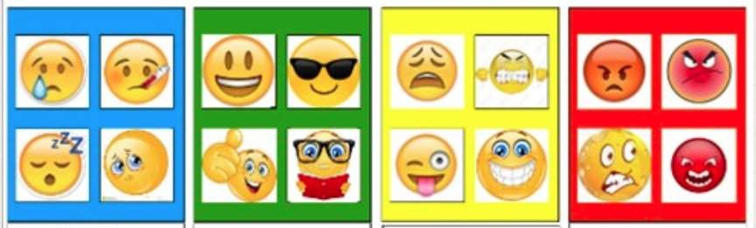

Learners are taught that all zones are ok. They are encouraged to develop their own individual toolkit of strategies to regulate their emotions that they can draw upon when they feel in a certain zone. It is important that adults don’t say things like, “What would help you get back to green?” as this implies the other zones are not desirable. Each emotion has its function. Below is an example of a toolkit.

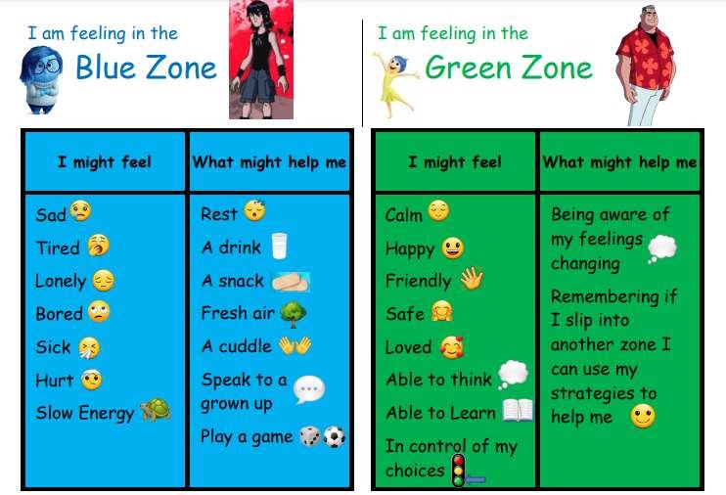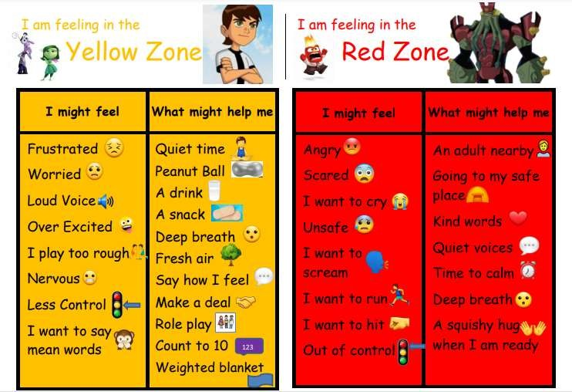

The Zones of Regulation was developed by Leah Kuipers and there is more information on this website: <https://www.zonesofregulation.com/learn>[-more-about-the-zones.html](https://www.zonesofregulation.com/learn-more-about-the-zones.html)

**Rewards:**

Our emphasis is on praise and rewards to reinforce good behaviour, rather than on failures. We believe that rewards have a motivational role, helping learners to see that good behaviour is valued. The commonest reward is praise, informal and formal, public and private, to individuals and groups. Staff know learners well and will adapt this according to the individual’s needs. It is earned by the maintenance of good standards as well as by particularly noteworthy achievements. This is as true for adults as for learners. Rates of praise for behaviour should be as high as for work. It should always be specific.

To praise, promote and reward positive behaviour, we use a range of rewards including;

* Verbal feedback / praise
* Non-verbal feedback *e.g. thumbs up gesture, smile*
* Stickers and certificates
* Certificates in celebration assembly
* Headteacher awards
* Growth Mindset Stickers
* Contact with parents – notes, emails or telephone
* Recognition in the school newsletter
* Website
* Share good choices with other adults for positive reinforcement
* Whole class reward time
* PomPoms

Rewards will be tailored to the age and stage of the class. Staff will use their professional judgement to decide what methods will be most motivating for their learners.

Class teachers are given autonomy over the strategies used for their class reward system within the following boundaries:

* There are individual and class rewards
* Rewards are bespoke and clear to all
* Any reward time is planned and purposeful
* Rewards must be engaging and motivating

It is important to note that some learners will struggle with rewards. What we are asking them to achieve may be beyond their developmental stage or the lack of reward may bring about a feeling of shame. Rewards can also become a threat, for example, if you don’t tidy up you won’t get a house point. Some children may compare themselves unfavourably with others depending on the rewards they achieve or become anxious about reward systems. Therefore, we recognise that reward systems are not appropriate for all children and appropriate adaptations may be made.

**Responses to Challenge Poor Behaviour and Support Learners**

**Initial Responses**

Reminders and warnings are used first. The manner in which they are given will be considered and adapted to best meet the needs of the individual child, so as to avoid creating shame or anxiety. If these warnings are frequent, they will be asked to reflect with an adult – this will involve a conversation that asks the child to think about their actions, the impact on others and what they will do differently next time (see reflection sheet in appendix 5). All children are different so the number of reminders given will depend on the individual child.

We believe that the importance of ‘relationship’ within the school community should not be underestimated. Where reflection is required ideally this should be done with the class teacher present. This is because they have the closest relationship in school with the learner and can support them going forward. Reflections are carefully managed to ensure they have minimal impact on everyone’s other learning.

By contributing to a safe, structured, open-hearted and stimulating sequence of interactions the adult can literally engage the child or young person’s brain capacity for emotionally connecting, thinking, memory functions of retention and retrieval, problem solving and meaning-making.

Some learners may have additional needs. This does not mean that our expectations are lowered but it does mean our response may be adapted, for example instructions may need to be repeated, visual supports used or additional chances to make good choices provided.

We use a range of strategies to interrupt poor behaviour choices including;

* Emotion coaching
* Comic strip conversation
* Classroom breakout spaces
* Sensory breaks
* Calm spaces in school
* Time in (time given to regulate with an adult to help them by co-regulating – this may be used in class or during playtimes – see more detail below)
* Change of environment with a supportive adult
* Social stories
* ‘Help’ card to initiate a change of face or space (see appendix 9 for more details)
* Awareness that there may be some spaces in school that create high anxiety e.g. head’s office – these will be avoided where necessary

If a learner is struggling to follow instructions despite repeated reminders and warnings, “time in” is used to help the learner calm and regulate their emotions. The learner is brought closer to an adult in the classroom and has some dedicated time with them. The rationale behind this is that the adult can help the child to regulate by co-regulating – this means helping the child to manage their emotions. Time in should be used for as long as it takes a learner to regulate.

|  |  |  |  |
| --- | --- | --- | --- |
| **Showing**  **LOVE - show care and**  **understanding for**  **others - be kind and caring, look after**  **others, think about**  **the views of others, accept difference** | **Showing RESPECT - valuing everyone and**  **everything in how you**  **listen, speak and in what you do** | Attunement= Presence + Curiousity – Maureen Campion**Showing CURIOSITY – asking questions, wondering why and being open to new ideas. Having a curious mind, allows us to consider others and have empathy** | **Showing**  **TRUST – telling the truth so that problems can be resolved, following instructions and rules to develop relationships based on trust.** |

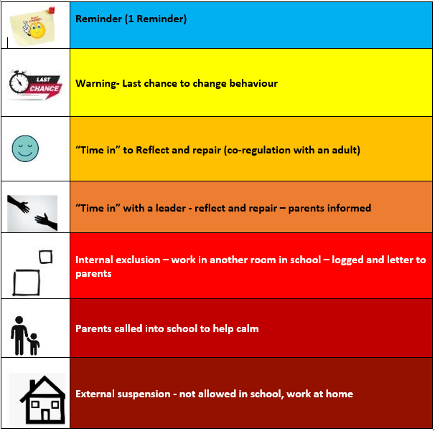

Emotion coaching is used throughout interactions. This strategy was developed by a psychologist called Dr John Gottman (1996). He identified that learners who were helped by adults to understand the different emotions they experience, why they occur and how to handle them were better able to control their impulses and delay gratification, self soothe when upset, have better attentional capacity and increased motivation, performed better academically and were better able to function in social relationships.

**Next Steps:**

Where a need has been identified the school may also put steps in place to scaffold a pupil who is at risk of not being able to manage their choices appropriately. We may use behaviour plans (see appendix 10 for more details) to ensure:

* extra support is structured and planned
* everyone knows the appropriate steps
* a consistent approach is followed
* adults feel supported

**More serious incidents:**

There are some situations that will provoke a more severe response from school. If a child deliberately commits any of the following, they may be given an immediate suspension at the Head Teacher’s discretion following a full investigation:

* Physical assault against a pupil
* Physical assault against an adult
* Physical aggression, verbal abuse, derogatory language (including name calling) / threatening behaviour against a pupil
* Physical aggression, verbal abuse, derogatory language (including name calling) / threatening behaviour against an adult
* Bullying (including cyberbullying, prejudice-based and discriminatory bullying)
* Racist abuse
* Damage
* Sexual misconduct
* Theft
* Persistent disruptive behaviour

Fixed Term suspensions may be either Internal where the pupil will attend school but learn away from their class (for an agreed period of time) or an External suspension, which requires the pupil to undertake their learning off site. In the case of an external suspension, this will be registered with the local authority. All exclusions will be appropriate according to age and stage of the child.

Following suspension, the learners and parents will be called to a ‘reintegration to school’ meeting and a behaviour support plan will be initiated where appropriate. Parents are always informed by standard letter if an internal exclusion or external suspension has been given.

Throughout all our responses to behaviour, we recognise that our partnership with parents and carers plays a vital role in ensuring good outcomes for learners. We will work, wherever possible, in agreement and consult fully on actions and next steps.

It is imperative to recognise that behaviour is never black and white and so often discussion is required to decide on next steps. All staff need to remember to use members of the team to support their thinking and decision making.

If an incident occurs at the end of a day the consequence will happen on the following morning. In some cases where this will be detrimental we will consider alternatives for example a conversation after school so that the incident can be closed and a fresh start made the next day. This is especially applicable if incidents happen on the last day of the term – carrying something over a holiday would be detrimental for mental well-being of all involved.

In very exceptional circumstances it may be necessary for alternative provision to be sought. In these cases we formulate a personalised approach, working closely with West Sussex outside agencies.

Link to DfE suspensions and exclusions guidance: [https://www.gov.uk/government/publications/schoolexclusion](https://www.gov.uk/government/publications/school-exclusion)

**Follow up after incidents**

We acknowledge that incidents can have a wide reaching effect of other members of the school and so the following strategies may be used to follow up after an incident:

* talking to individuals involved
* if appropriate talking to the whole class and encouraging them to ask questions
* explaining the consequences to all involved so they know action has been taken
* reflecting back to the core values – not normalising poor behaviour
* understanding that emotions are strong, real and effect behaviour
* acknowledging that some behaviour is not ok
* acknowledging we all need help to regulate even as adults
* explaining that learners can help each other

It is recognised that repairing significant relationships following an incident is especially important. For example, if a pupil has hurt an adult and so been given an internal exclusion, then time will need to be made for the pupil and adult to repair their relationship by, for example, playing a game together before the return to class. Being asked to apologise can be really shaming, so any act of putting right damage done should be accepted. E.g. the child could make them a card/draw them a picture/lend them something/ask them to play/write them a note. When relationship repair is needed, an adult often has to take the lead as the child cannot/does not know how to or feels too bad to do so.

**“Thinking of a child as behaving badly disposes you to think of punishment. Thinking of a child as struggling to handle something difficult encourages you to help them through their distress.”**

### **The Gottman Institute**

**Appendixes**

Appendix 1 - Visual tool for classroom to show steps to address poor behaviour

## Burstow Primary School Behaviour Support Steps

|  |  |  |  |
| --- | --- | --- | --- |
| **Showing LOVE - show care and understanding for others - be kind and caring, look after others, think about the views of others, accept difference** | **Showing RESPECT - valuing everyone and everything in how you listen, speak and in what you do** | Attunement= Presence + Curiousity – Maureen Campion  **Showing CURIOSITY – asking questions, wondering why and being open to new ideas. Having a curious mind, allows us to consider others and have empathy** | **Showing**  **TRUST – telling the truth so that problems can be resolved, following instructions and rules to develop relationships based on trust** |



### Appendix 2 – Last Chance Script (Warning – Last Chance to change behaviour)

Speak to the learner privately, suggest looking at the Zones of Regulation (display and or individual toolkit) and give them a final opportunity to engage.

Offer a positive choice to do so, and refer to previous examples of good behaviour.

*I noticed that you are…(having trouble getting started/struggling to get going/struggling with playing kindly).*

*The expected behaviour you have not shown is…(be kind and loving/be the best you can be/be respectful to everyone and everything).*

*You have chosen to (move to another seat/catch up with your work later).*

*Do you remember last week when you…(got that positive note/received a sticker/did that fantastic learning).*

*That is who I need to see today…*

*You need to…*

*I expect…(to see your table tidy in 2 minutes)*

*I know you will…*

*Thank you for…(give them take up time)*

### Appendix 3 - Emotion coaching – script – on all staff lanyards

|  |
| --- |
| **Emotion Coaching Script** |
| **Validate, Label, Empathise** |
| I can see you… (appearance - fidgeting)  I wonder if you are feeling…(name emotion)  I’m trying to understand how you are feeling  It is normal to feel like that/It’s ok to have those feelings |
| **Set Limits** |
| I’m worried that you are not showing our values and this means… Everyone needs to be safe so… |
| **Problem Solve** |
| What would help you now?  Maybe use Zones of regulation toolkit  (Give ideas if they can’t think of anything, When I’m feeling… I like to  … or compare to another situation when they have been successful)  Let the child choose the way forward |

26

Appendix 4 - Restoration script

Using restorative questioning/debrief:

* What happened?
* What were you feeling/thinking at the time?
* What do you think/feel about it now?
* Who has been affected by what has happened?
* In what way?
* What impact has this incident had on you and others?
* Which Core Value/Behaviour Expectation has not been followed?
* What has been the hardest thing for you?
* What do you think needs to happen to make things right?

**These questions are always neutral and non-judgemental; they are about a child’s behaviour and its effect on others. It should also be noted that for some learners, these questions will need to be asked when they are calmer and therefore not necessarily at the time of the dispute. It should be noted that ‘Why’ questions should not be used. It is the responsibility of the adult initially dealing with the incident to organise who will be carrying out the restorative questioning/debrief.**

In situations where a learner refuses to admit not following our Core Values and Behaviour Expectations, an investigation will take place to ascertain witnesses’ accounts. A decision of a consequence will be made on a balance of probabilities. There may be natural consequences, for example a learner who gets cross and tips a table up and his friend’s lunch goes all over the floor may experience the natural consequence of his friend being upset or cross with him/her. 27

### Appendix 5 – Examples of policy application

|  |  |  |
| --- | --- | --- |
| Behaviour | Example | Consequence |
| Following school expectations | Showing ready, respectful safe behaviour | Praise, rewards and positive recognition |
| Talking over the person speaking | Interrupting when someone else in class is talking | Reminder |
| Not following instructions | Everyone go and sit down – learner does not sit down | Reminder |
| Continuing to talk over the person speaking | Interrupting when someone else in class is talking following a reminder | Last chance |
| Continuing not following instructions | Everyone go and sit down – learner does not sit down despite a reminder | Last chance |
| Repeatedly not following instructions | Everyone go and sit down – learner does not sit down despite a reminder and a warning | Time in / Time out |
| Talking over the person speaking despite warnings | Interrupting when someone else in class is talking following a reminder and a warning | Time in / Time out |
| Persistent disrespectful behaviour to children or adults | Refuses to follow instructions related to verbal and/or non-verbal disrespect | Time in / Time out |
| Swearing directed at someone or a group | Swearing at another child in the lunch hall | Time in / Time out  Inform parents |
| Repeatedly throwing objects on purpose | Throwing several different objects | Time in / Time out  Inform parents / leaders |
| Unsafe behaviour | Walking away from an adult who is giving an instruction and going to an area that is out of bounds or physical altercation. | Time in / Time out  Inform parents / leaders |
| Hurting another (child or adult) on purpose | Walking over to a group and throwing a stick at them deliberately | Internal exclusion  Inform parents / leaders |
| Actions which deliberately and repeatedly distract others from learning | Banging on the windows of a classroom from the outside | Internal exclusion  Inform parents / leaders |
| Does not engage in internal exclusion | Refuses to follow instructions or do any work despite chances | Parents called in |
| Behaviour within internal exclusion continues | Continues shouting, throwing objects | Parents called in |
| Non-engagement in internal exclusion despite parent being called | Parents are present but will not settle to work and continues behaviour | Suspension |
| Deliberate repeated violence towards others | Punching another child on more than one occasion | Suspension |
| Deliberate extreme violence towards others which results in injury | Head butting another child which results in broken skin and bruising | Suspension |
| Persistent refusal to follow instructions which results in unsafe situations | Running into out of bounds areas despite numerous previous warnings and clear understanding | Suspension |

*Adults involved at original stage of behaviour should be involved in restorative conversations/follow-up

**These may vary for some children who have specific needs and where this is the case specific steps will be on their individual behaviour plan

It is important for parents and carers to remember that the adults in school use their professional judgement to make decisions about sanctions. **Parents and carers may not have all the information and so need to trust that the adults in school make careful and reasoned judgements**. We will listen to all views. So if you need extra information please just ask. An effective behaviour for learning policy relies on all adults working together and supporting each other. Permanent exclusion is only used in very rare cases – see Surrey guidance

**Appendix 6 – Behaviour Plan**

### **Behaviour Plan**

This pro forma has been adapted from the DfE Pro Forma on the DfE website

|  |  |  |  |
| --- | --- | --- | --- |
| **School:** | **Burstow Primary School** | **Learner:** | **Y** |
| **Class Teacher/s:** | **Miss** | **LSAs:** | **Miss** |

|  |  |
| --- | --- |
| **Assessment of Risk of Displayed Behaviour:** | |
| In which situations does the behaviour/risk usually occur? |  |
| How likely it is that the behaviour/risk will arise? |  |
| If the behaviour/risk arises, who is likely to be injured or hurt? |  |
| What kinds of injuries or harm are likely to occur? |  |
| How serious are the adverse outcomes? |  |

|  |  |  |  |  |
| --- | --- | --- | --- | --- |
| **Proactive Interventions to Manage Risk/Behaviour**  What we will do to prevent behaviour/risk | | | | |
| **Things that work well:** | | | | |
| − | | − | | |
| **Things to avoid:** | | | | |
| **Triggers:**   | | − | | |
| **Stages of Escalation** | | **Stages of challenging behaviour** | | |
| **Remember a child can re-escalate more quickly if recovery is not completed.**  Recovery often Tip – wait until fully calm before reflection | |  | | |
| **Early Interventions to Manage Risk/Behaviour**  Behaviour seen and the intervention we will use to manage the behaviour | | | | |
| **Signs/behaviour seen:** | | | **Interventions:** | |
| **\*PLEASE BE AWARE THAT Y CAN MOVE QUICKLY THROUGH THE STAGES\*** | | | | |
|  | | | | |
| **Stage 1:** | | |  | |
| **Stage 2:** | | |  | |
| **Reactive Interventions to Response to escalated behaviour**  What will be seen? What will we do to respond? | | | | |
| **Signs/behaviour seen:** | | | **Interventions and Positive Handling:** | |
|  | | |  | |
| **Recovery and Depression**  What will we do to help the pupil recover? Remember a depression may occur. | | | | |
| ➢ | | | | |
| **Follow-Up**  What will we do to follow up for the child and staff? | | | | |
| **For the pupil** | | | **For staff** | |
|  | | |  | |
| **Communication**  How will we ensure everyone knows this plan? | | | | |
| **Who?** | **How?** | | | **When?** |
|  |  | | |  |
| **Training needs**  Are there any training needs for staff? What will we do to meet these needs? | | | | |
| **Training need identified** | **Training provided** | | | **Date completed** |
|  |  | | |  |